ST BERNARDINE’S CATHOLIC SCHOOL
PARENTS & FRIENDS ASSOCATION
MINUTES OF MEETING
Tuesday 14 June 2016

Attendees: Darren Hutchison, Stacey Davis, Annette Darlington, Mischa Hawker, Catherine EMR, Isaac Naughton, Cherie Dalley, Kate Thomas, Steve Taylor, Scott Northfield, Allison Hawkes, Brad Eastall, Denita Castley, Simone Flanderka
Apologies: Lisa Downey, Julie Lawson, Jo Leitch, Nick Gallen
_________________________________________________________
Meeting opened in the new Library at 7.01 pm by – Darren Hutchison - President

Special Representatives:

Council Representative: Cherie Dalley
- Brochures and information guides provided for
  - Good neighbour guide
  - Environmental Events and Activities Guide provided from July – September 2016
  - Our Logan Volume 49
- Residents who were wondering about the Mt Lindsay Highway upgrade should have received a newsletter with future plans for Mt Lindsay/Logan Motorway. Copies provided
- Public art heritage launch LCC – The first of five proposed art and heritage trails – designed to raise awareness of arts, culture and heritage. It will link two city of Logan heritage “hot spots” providing 27 points of interest on a trail between Logan Village and Beenleigh. Makes for a great day trip for the kids finish off with a meal at Logan Village pub
- Let’s get moving Initiative includes NBN upgrade, Rail for South West Logan, and upgrades to Mt Lindesay Highway and the M1 – Campaign to have your say and to be heard by the federal government and opposition. You can help spread the word with bumper stickers and social media. A public meeting will be held on Thursday night – 16th June 2016. Mt Lindesay highway is one on the most dangerous highways in the state and requires and urgent upgrade and Southwest Logan need heavy rail transport
  - #saferMtLindesay Hwy
  - #railforSWLogan
  - #NBNforLogan
- Upgrades to Bayliss Road will see a new entry to landfill which will divert traffic off Browns Plains Road. Browns plains entry will be purely for the sports centre. There will be no right turn out on to Bayliss Road. It will remove heavy vehicles off Browns Plains Road. It is a safer alternative and priority.

Scott Northfield – Bendigo Bank
- Bendigo bank is a community bank and last year invested $300k back to the Logan Community
- The school and Bendigo bank have had a relationship for a number of years through use of P&F account and Eftpos for uniform shop.
- The Bendigo bank will review the current interest rates and apply Loading. Increasing the interest rate from 0.9% to 1%
- The P&F has sought Fun ding for dishwasher for Tuck Shop through Bendigo Bank through Crowd funding
  - The Bendigo bank would like to take the opportunity to partner with the P&F to raise funds to purchase the dishwasher
  - Parents are able to view offers by the Bendigo bank at www.letsact.com.au/banking
  - The crowd function account will be circulated between bank connection and school connections to acquire required funds
  - Once target hits 80% the bank will release funds on good faith. Approximately funding required is $4,500
  - Bendigo bank has generously donated $500 kick start to crowd funding account
  - Photos of the dishwasher will be added and the bank will upload the required information
  - Cherie has offered to donate towards the crowd funding account. Denita will provide if we provide further details.

- School banking – already exists with commonwealth bank. Bendigo won right to tender and can offer school banking.
  - The process is relatively simple: The school will gather bank books weekly and deliver them to the bank, the bank will process all the deposits and will deliver the bank books back to the school
  - The Bendigo bank already contract with another school and would like to offer to St Bernardines the chance to have school banking in conjunction with the commonwealth bank.
  - The bank is offering minimal fuss and a chance to grow with the kids and their banking needs
  - For every school account there will be a $10 for finder’s fee.
  - There will be trailers for new business and trailer for customers, extend offers to supporters of school through home loans, personal loans, credit cards, etc. and incentive to fundraise for crowd funding
Steve Taylor – Brisbane Catholic Education
- Invited to the P&F meeting by Nick Gallen to discuss the Educational brief being created
- The purpose of an education brief provides framework for school’s vision to facilitate master planning and development
- It communications the schools story and the history behinds each school
- The process provides opportunity for community to engage, and discuss the vision of the school and review the vision for learning
- It enables a review of the master plan and allows for funds to be expended as efficiently and effectively as possible
- An educational brief is used by architects, leadership team, staff and the parent community
- Upon completion, everyone should know where the school is headed for facility needs and what has been carefully considered
- There are four sections of brief that relate to strategic renewal and are connected to each other
  - Community profile contains the history of the school, the background, name of the school and the patron saint, the demographics and social economics,
  - Education context contains impact on all schools (i.e. national curriculum), phases of learning, how is the school organised in phases of learning (which year levels work together), RE guidelines,
  - Learning and teaching profile includes things that relate most specifically to St Bernardines, particular approaches, BCE promotion particular approaches, such as visible learning, factors relating to library (how resource is used), student support (particular needs and management), professional needs of staff, and sustainability
  - Organisational profile includes practical elements, such as how the school is organised, is there a spine, where would the admin be, leadership structure and how they work together, parent community, resourcing
- The education brief aligns with the schools strategic renewal planning and informs the school renewal annual goal setting

Community Profile

Organisational Profile
Educational Context
And
Learning and Teaching Profile

Facilitates Brief and Master Plan

- The education brief will be shared once initial drafts have been finalised.

Minutes from previous meeting are accepted as a true and accurate record.

Moved: Annette Darlington
Seconded: Isaac Naughton

Business arising from minutes
- Hall fans still coming and looking to be installed after winter. Two other schools have been consulted, one noted that they were noisy, but they had a much smaller hall volume. The other school has a hall much the same as ours and there are no significant sound issues. The fans are variable speed, and so can be slowed down if the noise becomes intrusive. Proposed: Isaac Seconded: Annette, approve unanimously. Darren to contact supplier. Update: Fans are underway and will be delivered soon. It is anticipated fans will be installed during the second week of school holidays. The school to pay the contractor and the P&F will reimburse the school. Denita to provide final costs. Darren to give contractor Nick’s details, as he will be away on holidays. Fans have been colour matched to ceiling.
- Power issues with water bubblers and so an electrician is needed to do the work – Electrician has reviewed the requirements. Darren has ordered the bubblers and there is a two week wait, but this will fit in nicely with the work required from the electrician. Update: This issue has been fixed. Two new bubblers have been ordered and needs to be collected. Darren to install before he goes on leave.
- An oven certainly needed 1 x 900 wide oven and the committee agreed that an oven should be purchased – Quote being sourced for the oven (quote was received, but was for a different appliance). Quote for cabinetry $3,740, a second quote has also been sourced, and these will be assessed together. Update: The new oven and cabinetry has been ordered. The school to pay the contractor and P&F will reimburse the school.
- Dishwasher – Bendigo Bank will facilitate a crowd-funding process for the purchase of a dishwasher for the tuckshop. Update: As discussed above, funding will be sought through Crowd Funding partnership with Bendigo bank.
- P&F shed to be purchased. Update: Three quotes sourced. Cheapest quote $6,420. All quotes assessed and this represented good value for money without lacking on quality. The floor will be sealed and racking for storage is ready to go.
- Additional recycling bins – Update: A letter has been submitted to Bunning’s on a school letter head. Currently waiting on a response.

Principals report – By Denita Castley
- It’s the busy time of term – Currently in the middle of parent teacher interviews. Most interviews have been completed with a few more to be completed tomorrow and Thursday. A big thank you to the teachers for their time. All the interviews have gone well however, it’s been noticed that the uptake of parents participating in interviews has decrease. This could possibly be a result that regular communication between parents and teachers have decreased the need to have a formal meeting
- Prep – Year 2 Athletics carnival on Monday 20 June – Coffee van available
- 21-23 June Athletics Week Field Event Finals for shot put, etc
- Friday 24 June – Events held all day - Snow Cone van available
- The years 5-6’s have just finished interschool sport. The Soccer team have won the finals in districts. Juniors touch football have come 3^{rd.} Excellent results by all teams
- Report cards have been written and are currently being proofreading. Report cards are due to come home next week in portfolios. Report cards can now be viewed online in the Parents portal. The portal currently has Semester 2 2015 report cards available. Report cards can be printed from portal and will be displayed in PDF format. The system capabilities at the moment can only hold 2 years of reports. It is recommended parents download or print a copy of the report to ensure they have a copy for their own records
- Parents will also be able to view Naplan results in the portal, when they are release in September.
- The school aims to be paperless by Semester 2

Correspondence
- Audit Report received 2 June 2016 – Further details in the treasurers report.

Treasurers Report –
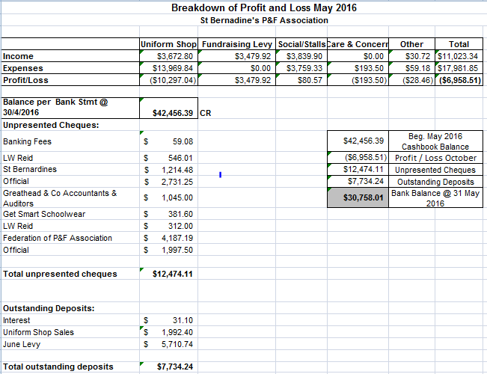
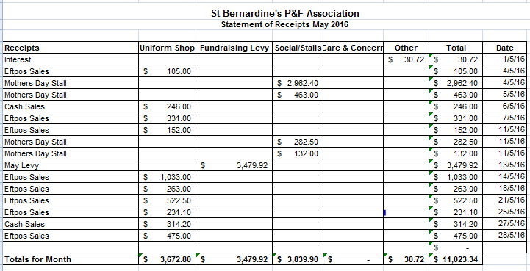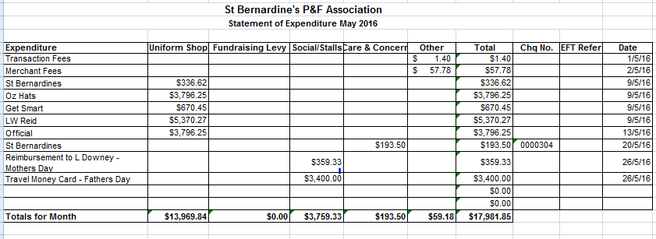

- Quiet Month for June. Total income $11,023.34 comprising of uniform shop sales, fundraising levy and Mothers’ day Stall. Total outgoings $17,981.85, which consists of uniform shop purchases, transfer of fathers days stall to travel money card
- Payment for the Federation of P&F Association received this week and sent for payment. Total cost $4,800.
- Audit report was received 2nd June – No issues identified. Auditor’s opinion: The financial statements of the St Bernardine’s Parents and Friends Association present fairly the financial position of the Association as at 31 December 2015 and the result of its operations for the year then ended. A copy of the audit report has been provided to the school. Noted that audited fees have increased 5.5% from prior years. Invoice has been sent for payment this week.

Uniform Shop report –
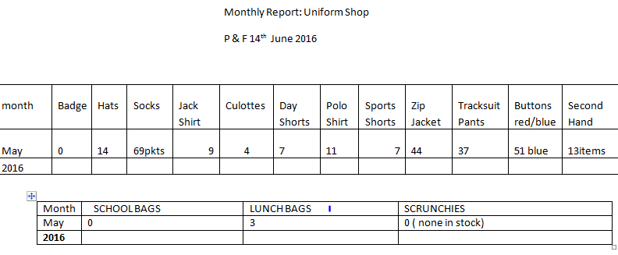
- Nothing much this month however did have a parent with an issue with a pair of track pants. The hem had come undone on the bottom of one leg. I think it would be from the child stepping on the hem, mum doesn’t, wanted them repaired....in the end Jamie (mum who helps me) is fixing them.
- Parent with the polo shirt issues came to see me. I informed her that P & F agreed that it was normal wear and tear; she seemed fine with the decision.
- I will be doing stock take on Friday 24th June and placing orders as required, will need to place an order for hats in preparation for Prep orientation day early to mid next term so that we have them in time(they take approx 6 weeks)
General business
- Parents have noticed new cleaner is doing an excellent job. Cleaning from 3.30pm - midnight

Meeting Closed: 8.02pm
Next Meeting: Tuesday 12th July, 2016 at 7pm, in the Library.

