**ST BERNARDINE’S CATHOLIC SCHOOL**

**PARENTS & FRIENDS ASSOCATION**

**MINUTES OF MEETING**

Tuesday 10 May 2016

**Attendees:** Jo Leitch, Lauren Harrison, Tory Jackson, Mischa Hawker, Nick Gallen, Darren Hutchison, Stacey Davis, Cherie Dalley, Denita Castley, Simone Flanderka, Isaac Naughton, Annette Darlington, Stefania Kleynendorst

**Apologies:** Lisa Downey, Julie Lawson, Kate Thomas

_________________________________________________________

Meeting opened in the new Library at 7:05 pm by – Darren Hutchison - President

**Cherie Dalley:**  Cherie provided a number of brochures including free immunisation, senior pets for senior people.

*Green Road footpaths* to be installed with bikeway path. Powell Park: Major community consultation to be undertaken. Receipt of the newsletter is much appreciated. *Seats in bus stops* is in progress with State Government. *Walk-in bus* to be trialled in Term 3 if we can get the volunteers. The walk-in bus idea is a stop a small distance away from the school to encourage healthy commuting by providing a short walk from the bus stop to the school. A trial is proposed for term 3.

**Minutes from previous meeting are accepted as a true and accurate record.**

Annette queried the record that size 18 jumpers will be sold at cost. This is not the case, and a small mark-up will apply as with any other size.

Moved: Annette Darlington

Seconded: Jo Leitch

**2IC for tuckshop funding:** P&F will fund until the end of the year at which point it will be assessed for viability (November P&F meeting).

**Quote for cabinetry** $3,740 was the quote, a second quote has also been sourced, and these will be assessed together.

**Business arising from minutes**

* Hall fans still coming and looking to be installed after winter. Two other schools have been consulted, one noted that they were noisy, but they had a much smaller hall volume. The other school has a hall much the same as ours and there are no significant sound issues. The fans are variable speed, and so can be slowed down if the noise becomes intrusive. **Proposed:** Isaac **Seconded**: Annette, **approve unanimously**.
* Power issues with water bubblers and so an electrician is needed to do the work – Electrician has reviewed the requirements. Darren has ordered the bubblers and there is a two week wait, but this will fit in nicely with the work required from the electrician.
* An oven certainly needed 1 x 900 wide oven and the committee agreed that an oven should be purchased – Quote being sourced for the oven (quote was received, but was for a different appliance)

**Principals report – By Nick Gallen**

* Children in Years 3 & 5 undertook NAPLAN. This provides useful data, but needs to be considered in the overall context of student assessment
* Prep interviews are underway. We currently have a waiting list of around 10.
* Well-being week. Wellbeing activities for staff and students. This will include no homework for the kids over that week. Coffee van will be financed by P&F
* Official thank you to Lisa Downey and all the parents who assisted with the Mothers’ Day Stall.
* Free Dress day (gold coin donation) on St Bernardine’s Day 18 May.
* New Building is complete. Furniture, fittings and technology to be installed in due course.
* ANZAC day well represented by the students. The children represented the school very well.
* Masterplan – The P&F will receive a briefing on this at the next meeting. If you want to know what is being considered for the school, please be sure to attend the next meeting.

**Correspondence**

* Recycling Bins: Local City Council can supply them, but there will be a cost with an annual rate charge of $65 per bin per year and assumes the bins are curbed each week. Browns Plains Bunnings has also been suggested. The bins are $110 each, but we may be able to get them as a donation. Nick suggested we hold off until we hear about the Masterplan.
* Dishwasher – Bendigo Bank will facilitate a crowd-funding process for the purchase of a dishwasher for the tuckshop.

**Treasurers Report –**





* Mothers’ day Stall
  + 1600 items for sale, 24 left by the end.
  + 11 Mums assisted – thanks to those individuals.
  + White slips $910 outgoing with $447 returned after first round of notices. Some parents may not be aware that their child purchased gifts using the white slip. A $2 limit will be put on white slips for future stalls to contain losses.
  + Total monies banked to date $3,707.90, which includes $282.50 sold at the Mother’s Day liturgy breakfast.

**Uniform Shop report –**

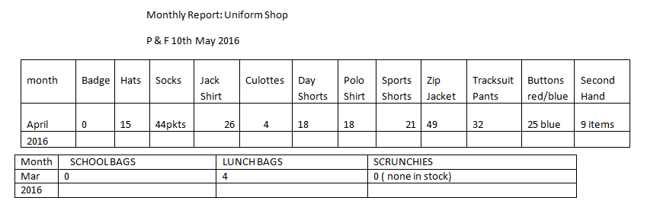

* A parent has approached Annette in relation to polo shirts bought at the start of the year. The clothing provider has retired and is no longer trading. The P&F determined that this is reasonable wear and tear.
* **Extra Hours 2016/2017:** The uniform shop will be open from 7:45-9am on Monday’s until the end of Term 4, this will commence week beginning 14/11/16 (3 extra days)
  + Friday 20/1/2017: 8:30-11:30 then 1:30-3:30
  + Saturday 21/1/2017: 9-1pm
  + Monday 30/1/17 and Monday 6/2/17 7:45-9am
  + Normal hours commence Tuesday’s 24/1/2017

**General business**

* A site was chosen at the rear of the school near OHSC and the caretakers sheds. A Stratco shed quote was also obtained. Quotes are being sourced. Size around 6.5x4m with slab and erected.
* P&F Levy will be reviewed in Term 3
* Disco date Term 4 – Week 3 – Friday 14th October. Prep-Year Two: 5.30-7pm. Year 3 to 6: 7:15-8:30pm
* End of year concert: 25 November. P&F will run a soft-drinks stall. Pizza van will be contracted again.

**Meeting Closed:** 8:25 pm

**Next Meeting:** Tuesday 14th June, 2016 at 7pm, in the Library. This is parent teacher night, so please take the time while you’re at the school to attend!